Assignment

Advance Data Science

Submitted by : Macharla Sunitha
EnrollmentNo. :2503B5125
Class :M.tech-1st year

Given the following data of Temperature (C) and Power Consumption (kWh):

Temperature (°C) (X) | Power Consumption (kWh)  (Y)
10 | 300
12 | 310
14 | 320
16 | 330
18 | 345
20 | 360
22 | 370
24 | 390
26 | 420
28 | 450

X | Y | X² | XY
10 | 300 | 100 | 3000
12 | 310 | 144 | 3720
14 | 320 | 196 | 4480
16 | 330 | 256 | 5280
18 | 345 | 324 | 6210
20 | 360 | 400 | 7200
22 | 370 | 484 | 8140
24 | 390 | 576 | 9360
26 | 420 | 676 | 10920
28 | 450 | 784 | 12600
ΣX=190 | ΣY=3595 | ΣX²=3940 | ΣXY=70910

Here,
Number of observations, n = 10
ΣX = 190
ΣY = 3595
ΣXY = 70910 ΣX² = 3940
Mean of X = 190/10
= 19
Mean of Y = 3595/10
= 359.5
Solution :(a). Derivation of Regression Equation
Y=a+bX
By Using Least Squares Method,
For a simple regression equation Y=a+bX :
slope, b = (n*ΣXY - ΣX*ΣY) / (n*ΣX² - (ΣX) ²)
Find numerator :
Numerator = n*ΣXY - ΣX*ΣY
=10*70910-(190*3595)
=709100-683050
=26050
Finddenominator,
Denominator = n*ΣX² - (ΣX) ²
=10*3940 –(190)²
=39400 – 36100
=3300
b = numerator/ denominator
= 26050/3300
=7.893939
Intercept , a = mean(Y) - b * mean(X)
a = 359.500000 - (7.893939)*19.000000 = 209.515152
Therefore the regression equation is
Y = (209.515159) + (7.893939)X
(b). Computation of R²
X (°C) | Y (Actual) | Ŷ = 208.7879 + | (Y−Ŷ) | (Y−Ŷ)²
 |  | 7.9848X
10 | 300 |  | 11.36 | 129.1
12 | 310 |  | 5.39 | 29.0
14 | 320 |  | -0.58 | 0.34
16 | 330 |  | -6.55 | 42.9
18 | 345 |  | -7.52 | 56.5
20 | 360 | 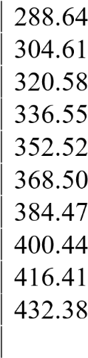 | -8.50 | 72.3
22 | 370 |  | -14.47 | 209.5
24 | 390 |  | -10.44 | 108.9
26 | 420 |  | 3.59 | 12.9
28 | 450 |  | 17.62 | 310.5
 |  |  |  | ∑(Y−Y^)²=971.9
Sum of Squares (Residual)
SSres= ∑(Y−Y^)2
= 971.9
Total Sum Of Squares
SS_{tot}= ∑(Y−Yˉ)²
=21530.7
R2 = 1 – (SSres/SStot)
=1 – 0.0451
= 0.9549

R² = 0.9549 = 0.955(approx.)

2 )
- Use Python (statsmodels) to fit model and compare.
- Interpret results (positive/negative slope, accuracy).
Regression Equation
Ŷ = 209.5152 + 7.8939X Using stats model the findings are:
Code:
import pandas as pd import statsmodels.api as sm
# Given data temperature = [10, 12, 14, 16, 18, 20, 22, 24, 26, 28] power = [300, 310, 320, 330, 345, 360, 370, 390, 420, 450]
# Create DataFramedf = pd.DataFrame({'Temperature': temperature, 'Power_Consumption': power})
# Define dependent and independent variables
X = df['Temperature'] Y = df['Power_Consumption']
# Add constant term for intercept
X = sm.add_constant(X) # Build the model model = sm.OLS(Y, X).fit() # Display the summary print(model.summary())
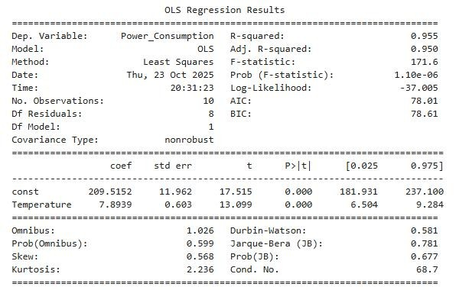
Conclusion :
- The fitted linear model has a positive slope, indicating that higher temperatures are associated with higher power consumption.
- The regression equation is Ŷ = 209.5152 + 7.893939 X
R² = 0.9555, which indicates the proportion of variance in Y explained by X

3).Using Python, perform Linear Regression on the dataset attached in excel format.
# Step 1: Import necessary libraries import pandas as pd import numpy as np from sklearn.linear_model import LinearRegression from sklearn.metrics import mean_absolute_error, mean_squared_error import matplotlib.pyplot as plt
# Step 2: Load dataset
# Replace with your actual file path file_path =
r"/content/drive/MyDrive/ADS/ASS_1/Experience_Salary.xlsx" df = pd.read_excel(file_path)
# Step 3: Separate variables
- = df[['Experience_Years']] # Independent variable
- = df['Salary_USD'] # Dependent variable
# Step 4: Create and train model model = LinearRegression() model.fit(X, Y) # Step 5: Get regression parameters a = model.intercept_ b = model.coef_[0]
print(f"Intercept (a): {a:.2f}") print(f"Slope (b): {b:.2f}")
# Step 6: Predictions
Y_pred = model.predict(X)
# Step 7: Model accuracy (R²) r2 = model.score(X, Y) print(f"R² (Coefficient of Determination): {r2:.4f}")
# Step 8: Error metrics mae = mean_absolute_error(Y, Y_pred) mse = mean_squared_error(Y, Y_pred) rmse = np.sqrt(mse)
print(f"Mean Absolute Error (MAE): {mae:.2f}") print(f"Mean Squared Error (MSE): {mse:.2f}") print(f"Root Mean Squared Error (RMSE): {rmse:.2f}")
# Step 9: Add predictions and residuals to dataframedf['Predicted_Salary'] = Y_preddf['Residuals'] = Y - Y_pred
# Step 10: Plot Regression Line plt.figure(figsize=(7,5)) plt.scatter(X, Y, color='blue', label='Actual Data') plt.plot(X, Y_pred, color='red', label='Regression Line') plt.xlabel('Experience (Years)') plt.ylabel('Salary (USD)') plt.title('Experience vs Salary (Linear Regression)') plt.legend() plt.show()
# Step 11: Residual vs Fitted (Predicted) Plot plt.figure(figsize=(7,5)) plt.scatter(Y_pred, df['Residuals'], color='purple') plt.axhline(y=0, color='black', linestyle='--') plt.xlabel('Predicted (Fitted) Values') plt.ylabel('Residuals (Y - Ŷ)') plt.title('Residuals vs Predicted Values') plt.show()
Output :
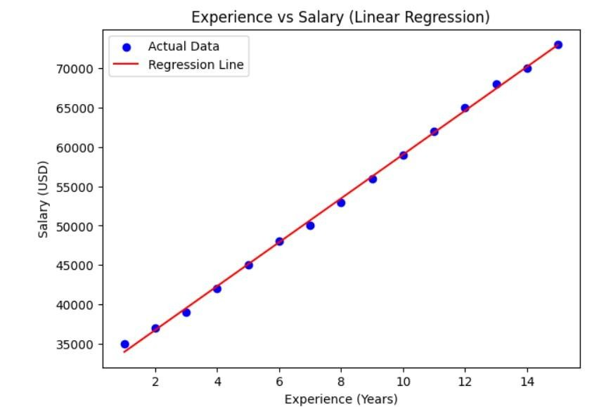
Intercept (a): 31180.95
Slope (b): 2785.71
R² (Coefficient of Determination): 0.9987
Mean Absolute Error (MAE): 345.40
Mean Squared Error (MSE): 191746.03
Root Mean Squared Error (RMSE): 437.89
